Year 12 Essentials 2021
Test 2

Data Collection and Graphs


Name: _________________________________

Time for the task: 50 minutes

Resources allowed – Calculator, 1 A4 (one side) hand-written page of notes Total Marks: / 43

Task weighting: 8%

Full working out must be shown to get full marks.

Attempt all questions in the space provided.

Question 1 [4 marks; 1 each]

Classify each of the following data collections according to whether they are a sample or census.
- Favourite film of secondary school students by surveying students in Year 12.

- Number of hours spent completing maths homework each week by your class by surveying each student in your class.

- Survey every 10th person in town to find out the towns average income.

- Asking everybody in the family what their favourite dessert is to decide what to cook for dinner.

Question 2 [6 marks; 3 each]

For each of the following investigations;
- State the population to be surveyed,
- Decide if a census or a sample should be used in collecting data.
- Give a reason for your answer.

- Student opinions of the length of lunch break at Baldivis Secondary College

- Find the average number of people in an Australian family.

Question 3 [2 marks; 1 each]

Give an example of how each of these sampling methods can be conducted.
- Random sampling:

- Systematic sampling:

Question 4 [4 marks]

Belinda jumps out of planes for fun. This can be represented by the linear function h = 1200 – 10t, where h is her height above ground at t seconds after she has opened her parachute.
Complete the table of vales for this function.

Time, t seconds | 0 | 30 | 60 | 90
Height, h metres

Question 5 [4 marks; 2 each]

Why are the following survey questions biased?
Rewrite the question so that it is unbiased.

- Are there enough events for young people in boring Baldivis?

- Rate how happy you are with the phone service in Baldivis:
□ Good □ Very Good □ Excellent

Question 6 [4 marks; 2 each]

In what way are the following samples biased? How could you get an unbiased sample?
- Surveying the maths teachers on what is the best subject at school?

- Asking teachers what music should be played at the Year 12 ball?

Question 7 [13 marks]

The table shows the linear relationship between the length of an international mobile phone call and the cost of the call.
BEBO INTERNATIONAL MOBILE PHONE PLAN
Length of call (minutes) | 1 | 2 | 3
Cost (dollars) | 7.7 | 14.5 | 21.3

- Draw the graph of the mobile phone plan on the axis below. [2 marks]
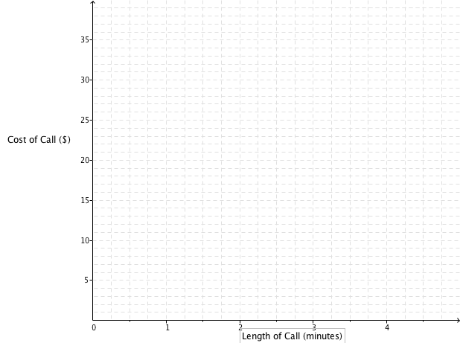

- What is the cost of a 4-minute phone call on this BEBO phone plan? [1 mark]

- What is the cost per minute for the BEBO phone calls? [2 marks]

- What is the rule to calculate the cost (c) of a phone call of (m) minutes on the BEBO phone plan?
[3 marks]

- GINTS international phone plan uses the formula c = 3.2m + 10. Draw this on the axis above.
[3 marks]

- Which mobile plan is better if I plan to make a phone call of 1.5 minutes? How much better would it be? [2 marks]

Question 8 [6 marks; 3 each]

Amy owns a bakery that makes cupcakes. It costs $2500 per month to cover rent, electricity and wages in the cafe. Each cupcake costs $1.10 to make and sells for $2.50.

- How many cupcake does Amy need to make and sell per month to break even?


- What profit or loss will she make in a month if she makes and sells 2500 cupcakes?

End of Test

